# Assignment 2

# Roll No: 2022201063

# Linux kernel setup

* Install oracle virtual box
* Add Linux 22.04 iso
* Run the linux 22.04 on VM
* Install linux kernel 4.9.210 : given command

wget https://www.kernel.org/pub/linux/kernel/v4.x/linux-4.19.210.tar.xz

* Extract : sudo tar -xvf linux-4.9.210.tar.xz -C/usr/src/
* Change directory to C/usr/src/linux-4.9.210

# Define system calls

1. System call to print welcome message to Linux logs

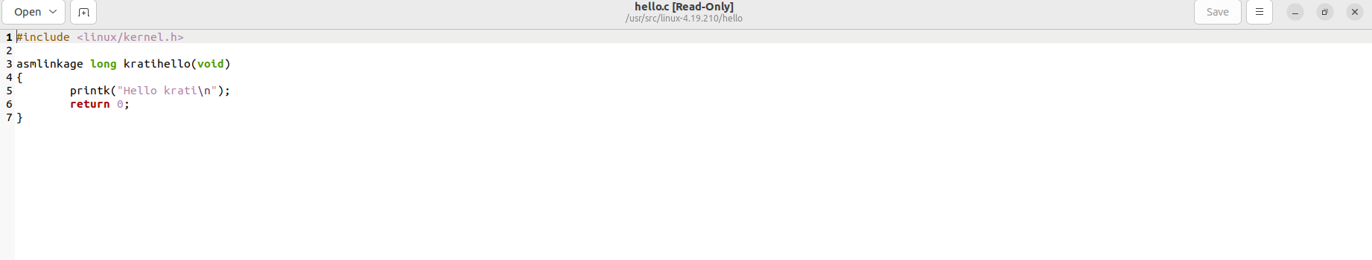

1. System call which will receive string parameter and print it along with some message to kernel logs

1. System call to print the parent process id and current process id upon calling it

1. System call to execute some predefined system call from your written system call

1. Fig shown is Makefile for 3rd system call, similarly for each system call we will create one Makefile since all system calls are in different folder

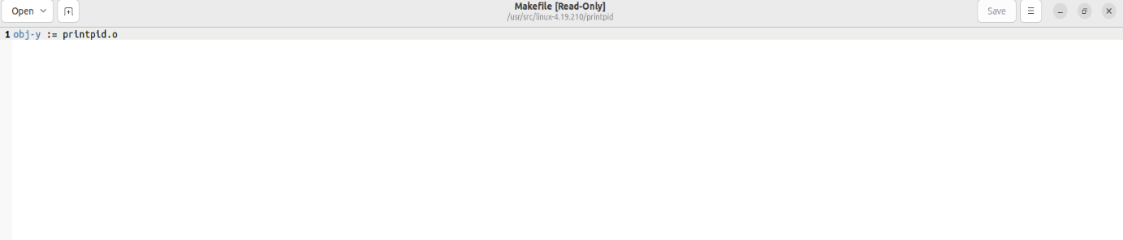

# Entry in syscall_64.tbl



Respective system call entries should be present in syscall_64.tbl table

cd cdarch/x86/entry/syscalls/  
gedit syscall_64.tbl



# Add system call in syscalls.h

Syscalls header file contain entries for our system calls declaration.

cd include/linux/  
gedit syscalls.h

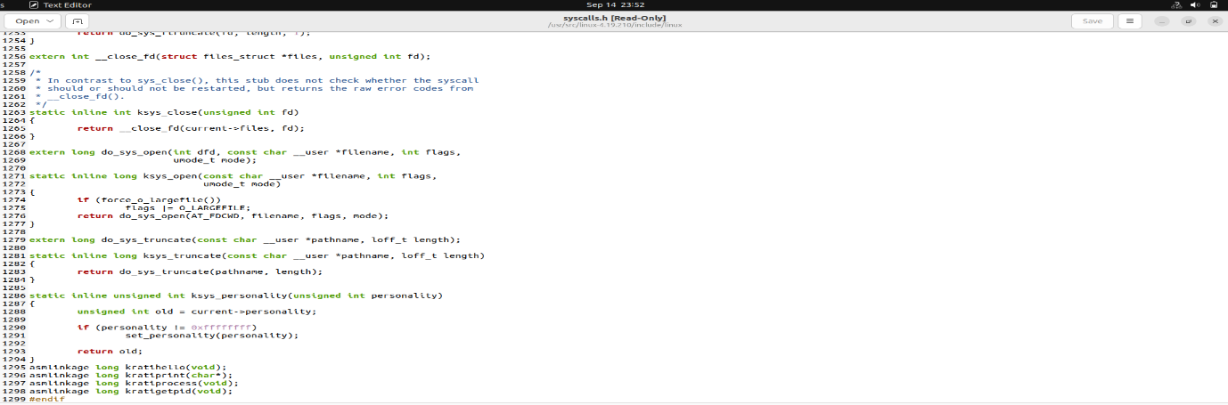

# Compile, install, update kernel

* sudo apt-get install gcc

sudo apt-get install libncurses5-dev

sudo apt-get install bison

sudo apt-get install flex

sudo apt-get install libssl-dev

sudo apt-get install libelf-dev

sudo apt-get update

sudo apt-get upgrade

* sudo make clean

sudo make

Fig: successful compilation of kernel

* sudo make modules_install install

shutdown -r now :to reboot and switch to linux kernel 4.9.210

# Test System call

1. Make one c file called userspace.c which will execute all system calls one by one using syscalls number as per the syscalls_64.tbl
2. Compile userspace file
3. ./a.out

1. Dmesg to print kernel logs

1. Output :kernel logs

Here the current process id and parent process id is different parent id is for the calling process while current process id is the id for current process.

# Some of the errors while compiling the kernel:

1. Certificate: inside .config file
2. Replace CONFIG_SYSTEM_TRUSTED_KEYS="/usr/local/src/debian/canonical-certs.pem" with CONFIG_SYSTEM_TRUSTED_KEYS=”"
3. After switching to linux kernel 4.9.210 black screen with initramfs failed to unpack.

Run this command: sudo update-initramfs -u -k all

Restart the system

1. Undefined references: use __x64_sys for system define calls